General Medical Officer (GMO) Manual: Clinical Section
Surface Warfare Medicine
Department of the Navy
Bureau of Medicine and Surgery
Peer Review Status: Internally Peer Reviewed

- Introduction

General medical officers assigned to ships and squadrons of the surface fleet are privileged to be a part of the most exciting part of the United States Navy. The surface force is the most traditional of all the branches of the naval service, and with the emergence of the doctrine of From the Sea, the surface force is the leading edge of the 21st century Navy.

- Organization

The surface force consists of all those ships not assigned to the submarine force or to the naval air force (i.e., aircraft carriers). Broadly speaking there are three categories of surface ships: combatants (shooters), amphibious assault ships (gators), and logistical support ships.

- Combatants
Aegis guided missile cruisers (CG), Arleigh Burke guided missile destroyers (DDG), Spruance destroyers (DD), and fast frigates (FFG) make up the surface combatants. Most of these ships are fast and heavily armed to provide air cover for aircraft carriers or hunt submarines, and bristling with the latest in computerized weapons systems. Their crew size is small (250-450 men) so most of these ships have independent duty corpsmen (IDCs) to provide medical care. Groups of ships are organized under the command of a destroyer squadron commanded by a Commodore, who is usually a captain or an admiral. Medical officers are assigned to regional surface support groups (RSG) usually commanded by a one star admiral who has responsibility for providing support to ships from several squadrons. It is the group medical officer's responsibility to teach and provide oversight to the corpsmen assigned to the cruisers and destroyers.
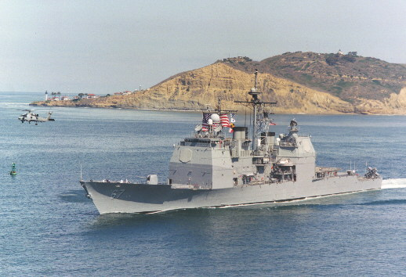

- Amphibious Assault Ships

- The amphibious assault ships are the heart of the Navy's current focus on Littoral Warfare. These ships include the Casualty Receiving and Treatment Ships (CRTS) of the Navy, the LHDs (landing ship helicopter dock), and LHAs (landing ship helicopter assault) . With their 4 operating rooms, 17 ICU beds, 48 bed ward, lab, x-ray, and blood bank capabilities, they are capable of receiving mass casualties and supporting fleet surgical teams. LPDs (landing platform dock) and LSDs (landing ship dock) are configured to launch LCACs and other assault craft from their well docks to carry Marines and their equipment ashore. LPDs, LSDs (41 class), and LCCs, while carrying a medical officer, have no ICU/post op beds and no blood bank capability. Ward beds number 13, 9, and 20 respectively.
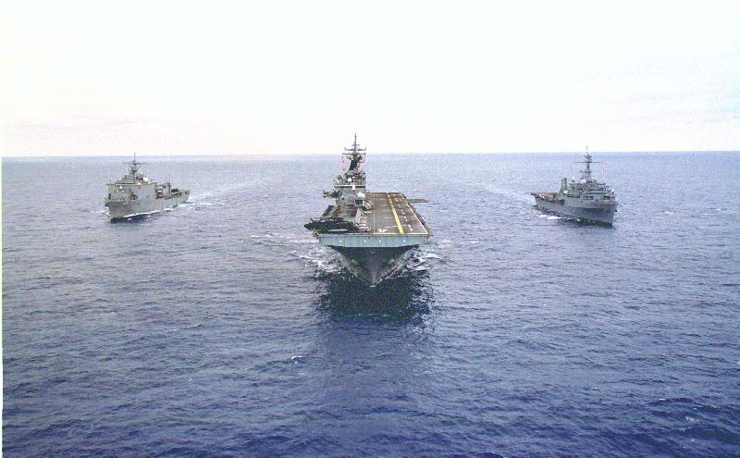

- The LHA and LHD are staffed generally with 2 medical officers, 1 dental officer, 1 medical service corps officer, and about 18 corpsmen and 4 dental technicians. The FST will bring a primary care medical officer (FP, IM, ER), a general surgeon, an anesthesiologist/anesthetist, charge nurse, OR nurse, medical regulating officer, 2 OR techs, a lab tech, respiratory tech, and 5 gen. duty corpsmen. LPDs, LSDs (41 class), and LCC have 1 medical officer, and 6, 5, and 12 corpsmen respectively.

- Logistical Support Ships
The sinews of war are logistics, and this class of ships is responsible for keeping the carrier battle groups and amphibious ready groups supplied during their deployments around the world. Oilers, ammunition ships, repair ships, and tenders are vital to the success of this country's national maritime strategy.

- Surface Medicine Pearls

General medical officers serving on surface ships have an opportunity to experience the traditional Navy at its best. As a medical officer aboard a ship of the line you will be expected to be more than a physician - you will also be expected to serve as a naval officer with all of the privileges and responsibilities of your commission. You will be thrust into a position of authority and responsibility as a department head or division officer. Remember the standards for a naval officer are high.

- As the ship's medical officer, you are directly responsible to the commanding officer; as the head of the medical department, you will be responsible to the executive officer. Your relationship with these two individuals will determine how enjoyable and successful your tour will be. The critical relationship is your relationship as the ship's medical officer to the CO. The CO is responsible for everything and everybody on the ship. By Navy Regulations, the commanding officer is specifically charged with the responsibility of the health and welfare of the men and women assigned to his or her command. Most commanding officers are very familiar with almost every facet of their command such as engineering, communications, supply, weapons, etc. However, for most, medicine and health care delivery systems are very unfamiliar. As a result, the commanding officer will rely on your professionalism as both a physician and a naval officer to advise him or her on how to best carry out their responsibilities to ensure the health and safety of the crew. You will be in a unique position to become one of the CO's most trusted advisors. Cherish that relationship and do everything you can to serve your CO with integrity and professionalism. To do so, you will need to learn as much as you can about the mission of your ship. Earning your Surface Warfare Medical Department Officer’s (SWMDO) pin will provide invaluable insight into you ship and its mission and will pay dividends with your fellow line officers upon which you will come to rely.

- Your relationship to the executive officer can often be a source of frustration for both of you. Unlike your relationship with the CO that is that of one professional to another in your role as advisor to the CO, your relationship to the XO is more down to earth. He or she is your administrative supervisor. He or she is much more likely to be interested in your day to day performance as a department head than the CO. It will become uncomfortably apparent that your administrative and leadership skills may not be on the same par as your medical skills and will not be commiserate with your new position as a sea-going department head. Although you have direct access to the CO, always be considerate of the XO and keep him or her informed of anything you plan to brief the skipper. Most of your daily routine will involve keeping the XO up to date on the status of the Medical Department and the impact of medical on the readiness of the crew.

- You will be expected to be many things onboard ship to many people besides the CO and XO. You will be called upon to be an administrator, chaplain, leader, family counselor, financial counselor, arbitrator, communications expert, legal expert, as well as handling collateral duties of a non-medical nature. And all the time you will be expected to practice high-quality medicine outside of a hospital setting.

- Your practice of medicine will include being proficient in family practice, occupational medicine, emergency medicine, infectious and communicable disease, epidemiology, surgery, and obstetrics and gynecology. You will be required to be knowledgeable about sanitary science, industrial hygiene, entomology and to know the medical intelligence data on the next port-of-call. You will become an expert in medical evacuation and the location and extent of medical care any place in the world.

- You cannot be expected to become an overnight expert. Therefore, recognize your limitations. Be aware that among your corpsmen there is a wealth of knowledge and experience. Listen to your senior corpsmen. It is folly not to seek out and use the expertise within your own department. Do not hesitate to tell your CO or XO or your patient that you do not know the answer if confronted with a new situation. Learn what resources are available to get help. Seek advice and followup from your fellow medical officers on other ships and squadrons and your consultants in the clinics and hospitals where you refer your patients. Become familiar with today's telemedicine capabilities including POTS (plain old telephone system), INMARSAT (the Navy's satellite phone system), and SALTS (the supply system’s method of sending messages).
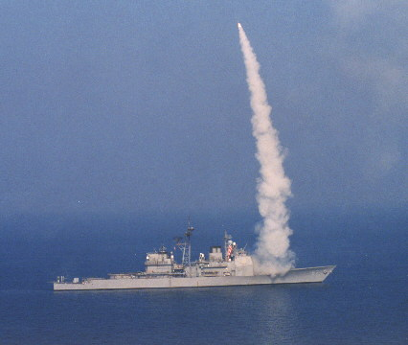

- What will be perceived as being equally important as your medical expertise, and what will make shipboard life infinitely more comfortable and rewarding, is your ability to quickly become accepted as a member of the wardroom. You must understand and accept that on board a Navy surface ship you will be viewed as a naval officer whose job happens to be practicing medicine. You will be living and dealing with exceptionally bright, educated, knowledgeable, and dedicated officers who are as expert in their fields as you are in yours. Accept and deal with them as such, become a part of the wardroom camaraderie, and life will be much more pleasant. Act as someone special or elite and you will be an unhappy, special, elite outsider. Seek out a fellow officer to be your mentor and help you learn the ways of the wardroom and proper naval etiquette. Don't be afraid to ask what the appropriate custom is for doing something aboard ship. Remember, almost all the other members of the wardroom have had years to learn the ins and out of life at sea. The process of acquiring the knowledge for your SWMDO pin is a great “face-saving” excuse to ask dumb questions. http://neds.nebt.daps.mil/Directives/1412_8a.pdf

- You will also never cease to be amazed at the intelligence and professional qualities of your enlisted medical support staff. You will find them eager and receptive. Obviously, the more you teach the better the crew. Remember that many of them have been in the Navy much longer than you have and will be able to help guide you through the maze of drills, inspections, and paperwork.

- Your first few months aboard ship will go by so quickly you will wonder how to do all the things that need to be done. By the time you are halfway through your tour, you will be more comfortable in your position. Take the time to enjoy your tour.

- When you salute the ensign and quarterdeck for the last time, you will leave knowing you have made a real and important contribution. The practice of surface warfare medicine can be likened to that of rural medicine. To paraphrase a rural physician upon his retirement, surface warfare medicine physicians develop a tremendous bond with their communities. They become an integral part of it. They belong there. The rewarding part of an operational practice is often not seen until a physician leaves and then endures the resultant pangs as he or she suffers the loss of their unique bond with the community. It is hard to replace this kind of appreciation, despite the challenges. Physicians at the end of their careers often consider the years of surface warfare medicine to be the ones when they felt most like a physician. It is a certainty that as time passes, you will remember all the rewarding and fun times. This will be especially true when you meet a former shipmate and engage in the time-honored tradition of swapping sea-stories.

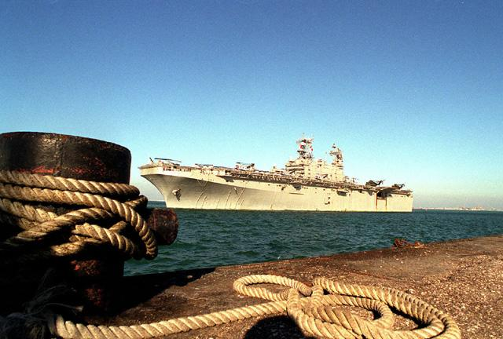
- Final words

For the surface medical officer, three very helpful, non-medical references include the Fleet Medicine Pocket Reference, Type Commander's Medical Guide (COMNAVSURFPAC/ COMNAVSURFLANT 6000.1), and LT Christian's Little Blue Book: An Unofficial Guide For U.S. Navy Shipboard Medical Officers that is also known. These will be distributed at the SWMOIC course before deploying onboard ship.

References

- OPNAVINST 1412.8A, Surface Warfare Medical Department Officer (SWMDO) Qualification and Designation, 1998.

- COMNAVSURFPACINST / COMNAVSURFLANTINST 6000.1

- LT Christian's Little Blue Book. An Unofficial Guide for US Navy Shipboard Medical

Officers, 3rd Edition, 1999.

Revised by CAPT Jay Montgomery, MC, USN, Surface Warfare Medicine (MED-22), Bureau of Medicine & Surgery, Washington, D.C. (1999).

