General Medical Officer (GMO) Manual: Clinical Section
Submersion Injuries
Department of the Navy
Bureau of Medicine and Surgery
Peer Review Status: Internally Peer Reviewed

- Definitions

- Drowning - death from suffocation by submersion in a liquid. If death occurs within the first 24 hours of a submersion incident it is considered a drowning death. (ICD-9 CODE 994.1)

- Near Drowning - Suffocation by submersion in a liquid with at least temporary survival. Death from near drowning occurs after the first 24 hours. (ICD-9 CODE 994.1)

- Wet Drowning - Fluid is aspirated into the lungs.

- Dry Drowning - Fluid is not aspirated, death is thought to be due to laryngospasm and glottic closure.

- Secondary Drowning - Death is within 1 to 72 hours after the initial resuscitation due to respiratory distress syndrome (RDS). About 15 percent of near drowning victims that are consciousness at time of initial resuscitation will die from secondary drowning.

- Immersion Syndrome - sudden death immediately following submersion in very cold water. Thought to be due to a vagally mediated bradysystolic cardiac arrest, or ventricular fibrillation. (ICD-9 CODE 994.1)

- Pathophysiology

The sequence begins with panic, struggle, and breath holding. This results in rapid development of hypoxemia and hypercapnea. At some point voluntary efforts at breath holding are overcome and aspiration of significant quantities of water may occur. Large quantities of water may be swallowed and vomited leading to aspiration of gastric contaminants.

Submersion

Aspiration
(wet drowning)
85%
Panic / Struggle
Laryngospasm
(dry drowning)
15 %

Hypoxia

Death

Respiratory and metabolic acidosis occurs from hypoxia and anaerobic cellular activity. Freshwater and saltwater will dilute/ washout surfactant leading to atelectasis, ventilation/perfusion (VQ) mismatch and destruction of the alveolar capillary membrane. This can occur with as little as 2.2ml/kg of aspirant. Non-cardiac pulmonary edema results from the direct pulmonary injury, surfactant loss, inflammatory mediators, and cerebral hypoxia.

Cardiovascular complications occur as a result of hypoxia, acidosis and hypothermia, not from the fluid or electrolyte shifts as previously proposed. For these shifts to occur, 10 to 22 ml/kg of water would need to be aspirated or the incident would have to occur in a very high solute environment such as the Dead Sea.

Supraventricular tachycardia (SVT) is common and may simply occur from hypoxia or a massive catecholamine release. The EKG may demonstrate Osborne Waves, a small notch on the descending R-wave that is associated with hypothermia.

Osborne Waves

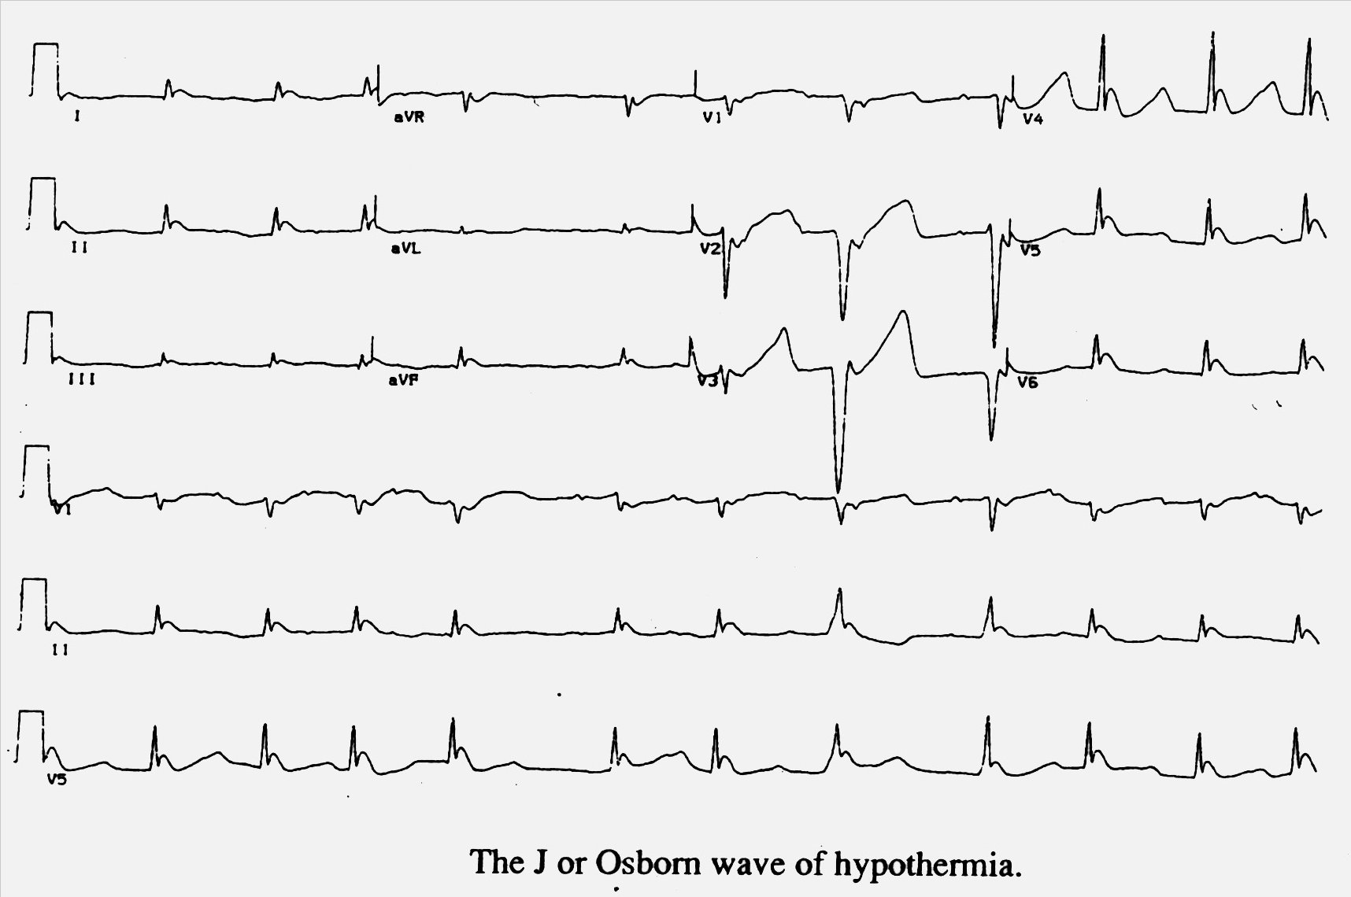

In very cold water, the diving reflex may account for cardiovascular collapse. Arrest seldom occurs from ventricular fibrillation except in cases of significant hypothermia (core body temperature <28 degrees centigrade). Central Nervous System (CNS) damage is caused by hypoxia and ischemic changes. This may be lessened in patients given CPR and in those who are hypothermic (due to its protective effect on the cerebral metabolism). Severe neurologic damage may occur in up to 15 to 20 percent of near drowning patients. However, 10 to 20 percent of patients that present in coma with fixed and dilated pupils who are aggressively resuscitated recover completely.

Other less common sequela are renal failure (anoxia, hemolysis, or rhabdomyolysis) and disseminated intravascular coagulation (DIC) (pulmonary endothelial damage, hypoxia, and acidosis).

- Pertinent History

- Circumstances surrounding incident including drug or alcohol usage.
- Duration of time submerged.
- Water temperature.
- Water contamination (i.e. sewage).
- Condition of the patient on discovery, initial extrication and during transport.
- General medical history.

- Medical Management

On scene:
- Initiate rescue breathing immediately.
- Extricate from the water using full spine precautions if mechanism of injury dictates.
- Re-evaluate airway, breathing, and circulation (ABC’s) and apply ACLS / ATLS measures as needed. Begin supplemental oxygen if available.
- Immediately transport to the medical department initiating measures to prevent further hypothermia.

In the medical department:
- Evaluate and treat ABC’s.
- Start an IV; administer 100% oxygen via nonrebreather mask, cardiac monitors and pulse oximetry.
- Perform rapid neurologic exam (GCS is useful).
- Expose and initiate rewarming if hypothermic.
- Use a low range thermometer (refrigerator thermometer will work).
- Raise the ambient room temp above 90 degrees.
- Infuse warmed IV solution as needed.
- Place warmed IV bags in axillas, groin, behind neck, and around scalp.
- Cover with warmed blankets.
- Perform a secondary exam. Pad spine board if unable to clear the spine clinically or radiographically.
- Insert a Foley to monitor urine output, state of hydration, and renal function.
- Place a NG tube (assure airway protection). Empty the gastric contents to prevent aspiration and improve ventilation.
- Institute standard supportive therapy.
- Observe closely.

When initiating the IV, draw lab samples. Depending on the ship’s lab capabilities, run a CBC, electrolytes, glucose, BUN, creatinine and coagulation profile. Obtain an ECG and chest radiograph. Continuously monitor pulse oximetry and the cardiac rhythm. Do not use steroids or antibiotics empirically. However, if the water was contaminated (i.e. sewage), appropriate antibiotic coverage (and immunization if applicable), should be initiated. If the mechanism of injury is significant (e.g., fall from the deck of a ship or pier), institute full spinal immobilization during extrication from the water. Initial clues for CNS injury include priapism, Cushing reflex, and paradoxical respiration. Rescue breathing should begin in the water with supplemental oxygen ASAP. Lung drainage procedures generally do not improve tissue oxygenation significantly.

If endotracheal intubation is necessary because of hypoxemia, 5-10 cm of positive end expiratory pressure (PEEP) may be helpful. Observe very closely for circulatory compromise. The patient that presents in full arrest is not dead until he is warm and dead. Continue resuscitative measures until the core temperature reaches 33ºC (92º F).

- Disposition

If the patient is asymptomatic from the onset of the rescue through evaluation, observe in medical for 6 hours. If the patient remains completely asymptomatic during observation and has no lab, cardiac or radiological abnormalities, then discharge. If symptoms were noted at any point, observe the patient until the symptoms completely resolve at which time the patient can be discharged with close follow-up.

When should the patient be evacuated to higher level of care?
- Continued tachypnea, dyspnea, or cyanosis.
- Radiologic evidence of aspiration or pulmonary edema.
- Dysrhythmias or ECG evidence of cardiac ischemia.
- History of apnea, cardiac arrest, altered level of consciousness.
- Associated trauma.
- Significant co-morbid disease.
- Your department is overwhelmed with other patients.

Remember that near drowning sequel may occur rapidly; hence, continual monitoring while in medical is required.

- Pearls

- Get the help of a colleague or a consultant (radio, VTC, e-mail, plain old telephone service (POTS), global satellite communications (INMARSAT), etc). Share your findings and concerns. Keep good records.
- Consider other common military injury complications (blast injury, inhalation injury (carbon monoxide fumes, gas), and burns.

References

- Clinical Practice of Emergency Medicine 2nd ed. Ann L. Harwood-Nuss, Lippincott-Raven 1996.

- Emergency Medicine: A Comprehensive Study Guide 4th ed., Judith E. Tinitnalli, McGraw-Hill Inc., 1996

Prepared by LCDR Steven L Banks, MC, USN, Emergency Medicine Department, Naval Medical Center San Diego, San Diego, CA (1999).

