General Medical Officer (GMO) Manual: Clinical Section
Diving and Submarine Medicine
Department of the Navy
Bureau of Medicine and Surgery
Peer Review Status: Internally Peer Reviewed

- Physical Exams

Special physical exams of personnel involved in submarine duty, diving, and exposure to ionizing radiation, require a specific format and then review and countersignature by an undersea medical officer. Your reference is the Manual of the Medical Department (MANMED), chapters 15 and 16. Mistakes can adversely affect careers, jeopardize special duty pays, and place unqualified persons in medically high-risk environments.

- Medical Disqualification and Waivers
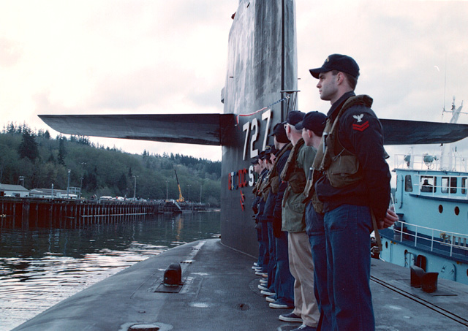
One reference for evaluation of disqualification and waivers is MANMED, chapter 15. There are several conditions that disqualify people from special duty. An independent duty corpsman is the only medical care provider onboard a submarine. Submarine duty is remote in nature and can preclude the immediate MEDEVAC of a patient. In some cases, days can pass before the “window of opportunity” exists for a MEDEVAC. This underlies the importance of careful screening of the crew as well as divers. Remember that bronchospasm in a diver at a depth of 150 feet may be a fatal event regardless of the type of medical care available.

- Waivers of disqualifying findings

Waivers of disqualifying findings are often appropriate but must be handled by strict administrative guidelines. Your personal opinion expressed on a SF 88 is not sufficient. A complete waiver package must be submitted. Consultation with an undersea medical officer is essential.

- Questions

If you have any questions on physicals, waivers, or disqualifications contact BUMED (MED-21), Undersea Medicine and Radiation Health at COMM: (202) 762-3444 or (DSN) 762-3444. Message PLAD BUMED I/2111 Washington DC.

- Diving Emergencies

- It is absolutely essential you keep available current phone numbers for the nearest recompression chamber (military or civilian) and the nearest diving medical officer (DMO). Diving Medical Officers are attached to submarine squadrons, groups, and larger diving units as well as Naval hospitals and some of the larger clinics.

- Two very serious conditions must be considered when you are evaluating a diver: decompression sickness (DCS or the Bends) and arterial gas embolism (AGE). Presentations are varied but ANY neurologic abnormality occurring minutes, hours, or even several days after a dive demands consideration for emergency hyperbaric treatment.

- Questions or comments call (24 hours a day):

- Navy Experimental Dive Unit (NEDU), Panama City, FL, COMM: (850) 230-3100, (DSN) 436-4351.

- Nuclear Weapons Personnel Reliability Program (PRP)

- This program applies to personnel who have access, or control access to nuclear weapons, or who are involved in training in the use of nuclear weapons.

- Look for the identifier in both of the health and service records.

- Reference (b) SECNAVINST 5510.35

- Drug and alcohol incidents require action on your part. Use of certain medications also may require notification. Take the time to look it up. Attention to detail is very important in the PRP.

- "No Dive Chit"

Temporary contraindications to diving include:

- URI, sinusitis, otitis media and/or conditions that interfere with equalizing.
- Acute bronchitis.
- Acute gastroenteritis.
- Alcoholic/drug intoxication; sedative or hypnotic use.
- Pregnancy.
- If there are any questions contact an undersea medical officer.
- Documentation
Document duty limitations on SF 600. Consult with a DMO for problem cases. Always keep in mind that a diver's life may depend on your ability to forecast a medical problem that is insignificant if it occurs on land but can be deadly while diving.

References

MANMED, Chapters 15 and 16

- SECNAVINST 5510.35

Revised by CDR Bruce A. Cohen, MC, USN, Officer in Charge, Naval Undersea Medical Institute, Groton, CT. (1998).

